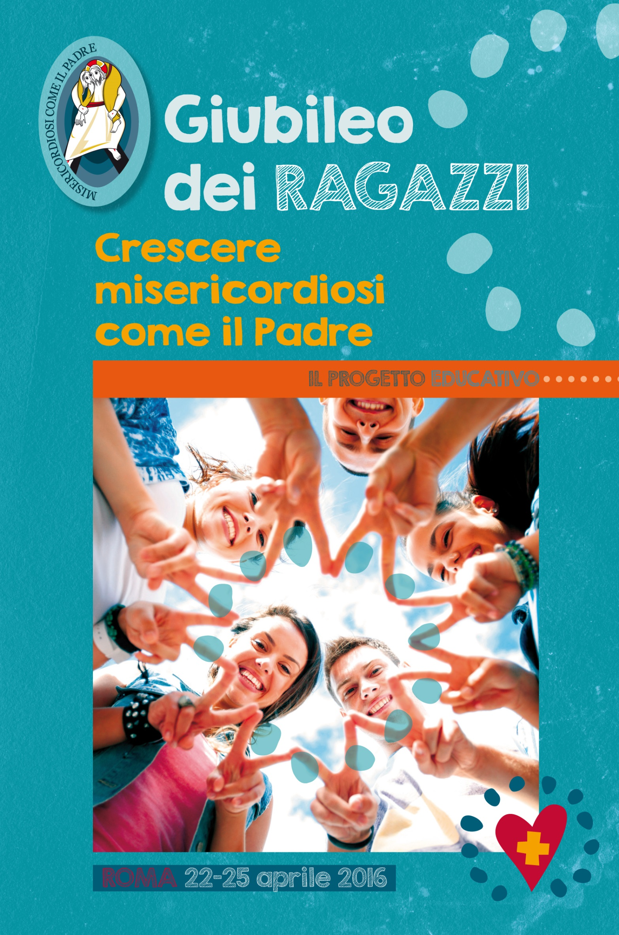
GENERAL INFORMATION ABOUT THE EVENT

You can find a detailed schedule for the Jubilee on the CEI website www.gmg2016.it and on the Pontifical Council for the New Evangelization site: www.im.va.

PENITENTIAL JOURNEY – PASSAGE THROUGH THE HOLY DOOR
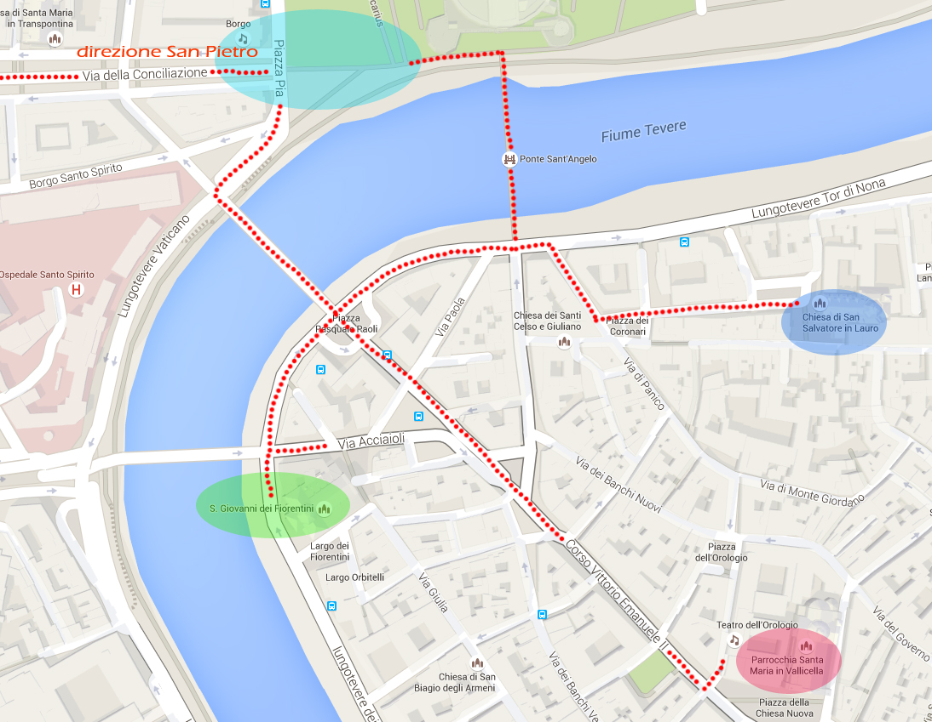

The journey begins with preparation for the Sacrament of Reconciliation. If they have not already done so while traveling to Rome, priests can prepare the youth in their groups for the sacrament at the 3 Churches dedicated to the Jubilee: San Salvatore in Lauro, Santa Maria in Vallicella (Chiesa Nuova) and San Giovanni dei Fiorentini. The route then proceeds from these Churches across either Ponte Sant’Angelo or Ponte Duca D’Aosta, to reach Piazza Pia in front of Castel Sant’Angelo, where the reserved walkway for pilgrims begins. The path continues up Via della Conciliazione to arrive, finally, at Saint Peter's Square.
The celebration of the Sacrament of Reconciliation will take place in Saint Peter's Square, inside the arms of the Colonnade, where confessionals will be set up.
Once they have finished confession, the groups will pass through the Holy Door. Inside the Basilica they will proceed to the Tomb of Peter for the profession of faith.
Attention! Access to the pilgrim route will be granted only to those who show the pass received in the Pilgrim Kit.

YOUTH RALLY
Those who have finished the Jubilee journey to Saint Peter's can proceed to the Olympic Stadium for the youth rally. The estimated travel time on foot from Saint Peter's is 2 hours. Along the way there will be stands for the distribution of a boxed lunch for the youth, available for those who have requested it according to the instructions with the online registration form.
The rally will end around 22:00.

HOLY MASS WITH POPE FRANCIS
On Sunday morning at 10:00 there is a Mass planned with Pope Francis. Depending on the number of pilgrims registered and present in the Square, there may be a separate seating area reserved for the pilgrims for the Jubilee for Boys and Girls. Anyone entering this area will need to show the Pass received in the Pilgrim Kit.

TENTS OF MERCY
Seven squares in the Central Historic District of Rome will host seven tents that will recount to the pilgrims, and to the citizens of Rome and of the world, testimonies about the spiritual and corporal works of mercy. The seven squares will be: Piazza della Minerva, Piazza del Popolo, Piazza Farnese, Piazza Navona, Piazza S. Maria in Trastevere, Piazza. S. Maria in Vallicella, and Piazza Pia at Castel Sant’Angelo.
Given the full schedule during the days, it will probably be possible to tour the center of Rome and visit the tents on Saturday either in the morning or immediately after crossing through the Holy Door (before going to the Olympic Stadium for the rally); or else on Sunday afternoon after the Mass; or, for those who extend their stay in Rome, during the day on Monday, April 25.

ON LINE REGISTRATION: General Information
Registration deadline: March 31

REGISTRATION FEE
The fee for participating in event is € 10.00 per person (including priests, chaperones, youth); registration supplies each participant with a Pilgrim Kit that includes, among other things, the name badge that permits pilgrims to access the penitential route, Saint Peter's Square, and the Youth Rally at the Olympic Stadium.
The Pilgrim Kit and Pass will be sent through a delivery service to the address of the group leader.
(delivery costs charged to the recipient)
Those who have registered as individuals or small groups should, instead, pick up their own Pilgrim Kit and Pass at the Pilgrim Information Center on Via della Conciliazione.

LODGING
On the registration form there is the possibility to request lodgings on the floor at Parishes, Religious Institutes and Catholic schools, for the cost of € 10.00. The accommodations are for 3 nights: from the evening of Friday, April 22 to the morning of Monday, April 25. The group leaders who request these lodgings will be subsequently contacted by the Organizing Secretariat with information about the location of their lodgings, but only after the registration deadline of March 31, and only after they have made the online payment of their registration and lodging costs.

It is also possible to request assisted lodging at hotels and other participating buildings, thanks to the support services of Vatimecum, or else through the Opera Romana Pellegrinaggi. More information about these resources and their conditions can be found on the registration form.

MEANS OF PAYMENT
Below are the bank coordinates to make the payment for your group. We remind you that under the heading “causale” (reason for payment) it is necessary to indicate the group code (which is automatically generated by the online registration system), the name of the group leader, and the following information:
Payee: Conferenza Episcopale Italiana
Bank: UNICREDIT
Acc't no.: 400002593
IBAN: IT 63O 02008 05037 000400002593
BIC SWIFT: UNCRITM1018
Indicate as the reason for payment: Group Code – Name of the Group Leader – Participation Costs

SERVICE PORTAL: www.vatimecum.com
Services for lodgings, meals, insurance, and cultural itineraries may be requested on the service portal, developed through an agreement between the Pontifical Council for the Promotion of the New Evangelization (PCPNE) and the Società Itineris which will manage the information content and offers for the whole Jubilee Year.
MEALS
The agreement between Itineris and the PCNE for a meal plan using meals tickets has a baseline price of € 5.00. The service will begin with breakfast on 23/4 and end with lunch (pranzo) on 25/4.
With a single ticket, you can acquire breakfast or a box lunch; with two or more tickets, used together, you can purchase a sit-down lunch or dinner in participating restaurants.
The company is putting together a map of all the food vendors (bars, take-away buffets, restaurants and trattorie) that will participate in this service for the entire Jubilee Year.
The map will be available and kept up to date on the service portal.
The vouchers purchased – which are marked with a barcode, and therefore may be used only once - will be sent by email directly to the group leader, who will then be responsible for their distribution.
A special ticket (only for the Jubilee for Boys and Girls) for a takeaway meal for the youth (but available for the entire group) is planned, which will be provided at the usual cost of € 5. The contents of the boxed meal will be specified on the web page of the service portal. This special meal ticket can be requested not only for Saturday, but also for Sunday and Monday; all the details of the offer are available on the portal site Vatimecum.
Unlike the generic tickets that may be used for breakfast and at cafes and restaurants, the youth meal tickets can be used only for this specific boxed meal service.
Distribution points for the boxed meals will be organized in the Central Historic Zone of Rome (Centro Storico) and along the route to the Olympic Stadium.
OTHER SERVICES
For other services for Lodging/Bookings, Insurance, and Cultural Itineraries, visit the site www.vatimecum.com.

TRANSPORTATION - BUSES - PUBLIC TRANSPORTATION
You can consult the prices for tour buses within the city on the site www.agenziamobilita.roma.it/it/permessi/pullman‐turistici. On the site www.Atacroma.it, you can find the prices set by the Comune di Roma for public transportation during the weekend.
The city management is not planning any special arrangements for public transportation for pilgrims.
Regarding the access of buses in the city, it will be possible for buses to enter to pick up and drop off passengers at their lodgings. At this time a plan for permitting buses to pick up passengers after the rally at the Olympic Stadium is still under consideration.
ONLINE REGISTRATION: Tutorial

Registration manual

Preliminary Information
To register you must fill in the anagrafic data requested for the group leader and the number of participants (if you do not have a final number for the group, supply an estimate).
The information inserted may be changed at any time by logging into your account. The form will be closed to modifications only once payment has been made by inserting the necessary information for the bank transfer of funds.
To obtain information about the event and the registration process it is NOT necessary to register.
Complete information can be found at the websites:
- of the CEI (Italian Episcopal Conference) - Youth Ministry for WYD (GMG) and the Jubilee
www.gmg2016.it
- of the Pontifical Council for the Promotion of the New Evangelization http://www.im.va/content/gdm/it/roma/grandi-eventi/2016-04-24-ragazzi.html
Additional information arrive periodically on the websites and through email.
Please do NOT make inauthentic registrations.
If you have already begun a registration that does not reflect actual participants for the event, please send us your registration information (name, surname and email address), and we will cancel the account.

Registration
There are two phases to the registration process.
- Creating a user ID by inserting your email and choosing a password
- Filling out the sections of the registration form.

Creating your user ID
To register your email in the system, click on the "Register" button on the home page

This will open the page seen in the illustration, which should be filled out with your personal information as the group leader, including the language with which you want to navigate the registration system.
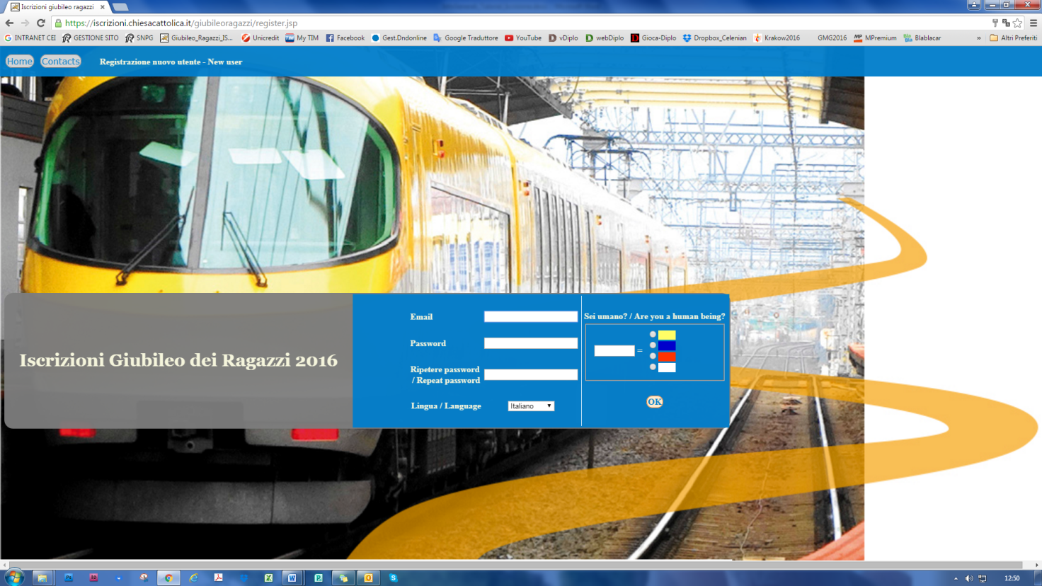
To finish this step it is necessary to "demonstrate" that you are a real person by selecting the color (chosen at random) that is displayed (“captcha”). This is to prevent false registrations by some automatic programs that circulate on the web.

Once this part of the registration has been sent, the newly established user will receive an email containing the user information chosen, and requesting a confirmation that the registration is correct.
At this point, the web page will automatically open to the first page of the questionnaire. The registered user may begin to fill out the form immediately, or may leave the system and return at a later time using the login ID and password now established.

Filling out the online form
The registration form contains 5 sections that must be filled out, as seen in the illustration, beginning with the information for the group leader and finishing with the section "Summary and Payment". In the last section, you can attach the receipts from the bank transfer(s) made. It is possible to pay in several installments.
The sections may be filled out in any order, but each one has required fields that must be filled out correctly. If these are not completed according to the instructions, the section cannot be accepted and the registration cannot be finished.
Registration is completed when all the obligatory information has been inserted in the correct way and payment has been completed for the full cost (by uploading the file(s) with the receipts from the bank transfer(s) received).
Once the registration has been completed you will not be able to change it. If you should later need to modify any information, use the contact form found by clicking on the button
A description of each section of the registration process follows:

Group Leader Information
In this screen you must enter anagraphic data for the contact person (leader) for the group. The following fields are obligatory: Last Name, First Name e Cell Phone Number.

Composition of the Group
The information requested in this section relates to the total number of participants in the group and its subdivisions into youth, disabled youth, chaperones, and priests; information about the group's place of origin and departure and arrival dates is also requested. The obligatory fields regard the total number of participants and the arrival and departure dates.
This section requires that the numbers entered correspond to one another; for example, the number of youth, chaperones and priests should equal the total number of participants, as likewise for the geographic subdivisions.
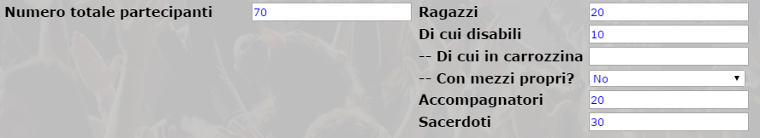

Means of Transportation
In this section details regarding transportation to Rome are entered, such as what means of transportation will be used, and how many people will arrive by which types of transportation, etc.
The registration system will check that the total number of participants corresponds to the sum of participants indicated for the various means of transportation, as well as for other logical errors - for example, if a means of transportation has been chosen without supplying the number of people using it.

Pilgrimage and Logistics
This section requests a confirmation of the number of participants who will attend the different parts of the Event (Pilgrimage of Mercy, rally at the Olympic Stadium, Holy Mass with Pope Francis).
Then the registration cost will be calculated according to the number of participants registered, and some options for lodgings will be presented, as described in the introduction above.

Summary and Payment
The last section is dedicated to uploading the receipt(s) of the bank transfer(s) made.
First, the subtotals and total costs are shown:
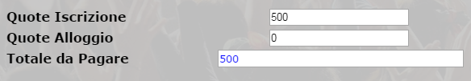
Immediately below is found the section for uploading a payment. Remember that payments may only be made with a bank transfer, for which the user can then fill in the information relating to the transfer, and upload the receipt from the transfer once it has been made.
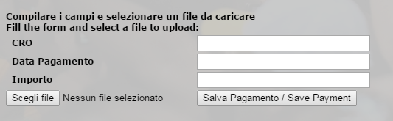
Note: The system can only accept files of the types: pdf - jpg - doc - docx
The fields “Date of Payment” e “Amount” are obligatory.
After the payment has been entered, it will appear on the list under the heading “Attachments and Payments Made”. From there you can see files already uploaded (click on "Received"), modify the information entered in case of an error (CRO, date and amount), or completely delete a payment.
ATTENTION! If the payment being entered will be the final one, the system will note that the registration is complete, and that it will no longer be possible to change it.
Before accepting the payment, however, the system will warn the user that the registration will be closed:
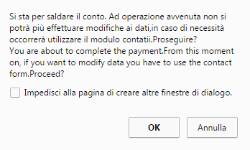

Other Operations

Contacts
At any time you may contact the administration of the system with the form "Contacts". This form uses a “captcha” system requiring that you identify a color, if the contact request occurs without a prior login.

Print
The print button, present in each section, prints all of the pages with the information entered into them in one document.

Change Password
By clicking here, the user can change his/her password

